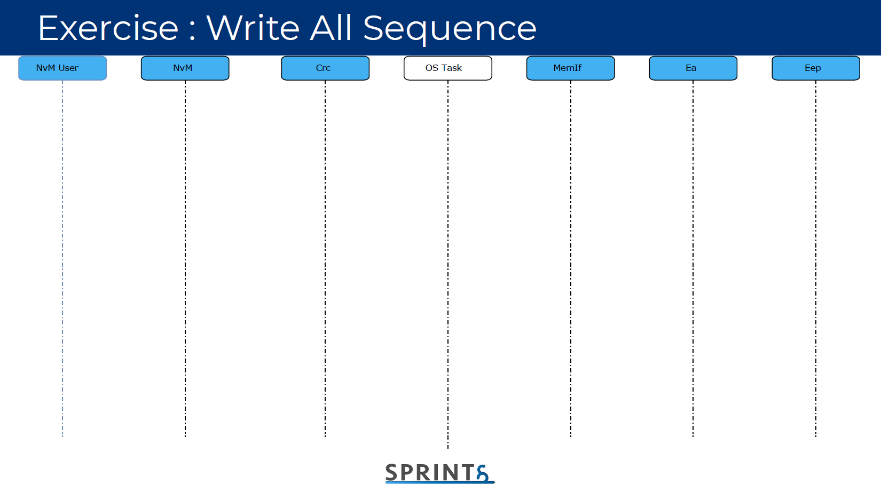

Cyclic

Cyclic

return

**return**

**Single_callbackNotification**

**NVM_MainFunction**

**return**

**Ea_JobNotification**

**return**

**return**

**Eep_MainFunction**

**Eep_JobNotification**

**MemIf_Write**

**NvM_WriteAll()**

**Eep_MainFunction**

**return**

**return**

**Eep_Write**

**return**

**Ea_Write**

**return**

**return**

**NVM_MainFunction**

**return**

**CRC_CalculateCRC**

return